A Beginners Attempt at SQL

By

Israel Nolazco

In this document we are going to explore some SQL commands utilizing two samples tables. We are going to display specific pieces of a table, make calculation and modifications to specific entries to our tables. To start off we are going to show our two tables we are currently going to use.

Employees Table

|  |  |  |  |  |  |  |  |
| --- | --- | --- | --- | --- | --- | --- | --- |
| D | FirstName | LastName | Age | Dept_number | City | State | Salary |
| 1 | John | Smith | 45 | 100 | Chicago | IL | 1000 |
| 2 | Jane | Doe | 25 | 100 | Phoenix | AZ | 5000 |
| 3 | Mary | Smith | 40 | 200 | Chicago | IL | 2500 |
| 4 | George | Edwards | 50 | 300 | Phoenix | AZ | 3000 |

Departments Table

|  |  |
| --- | --- |
| Dept_number | Dept_Name |
| 100 | HR |
| 200 | IT |
| 300 | Accountin |

These two tables are going to be loaded into our Shell and run a program call sqlite3. This program runs an environment similar to SQL big players like Oracle, MySQL, ect. Below is the image of the two tables created whilst displaying their contents.

Now that the tables have been created, we are going to run seven different exercises.

1. Display the first name, last name, department name and age of all employees. Note you must display the Department Name and not the department number.
   1. Display the same information ordered by Last Name
   2. Display the information in decreasing order of Age

Answers:

1. SELECT Employees.FirstName, Employees. LastName, Employees. Age, Department.Dept_Name

FROM Employees

INNER JOIN Department

ON Employees.Dept_number = Department.Dept_number;

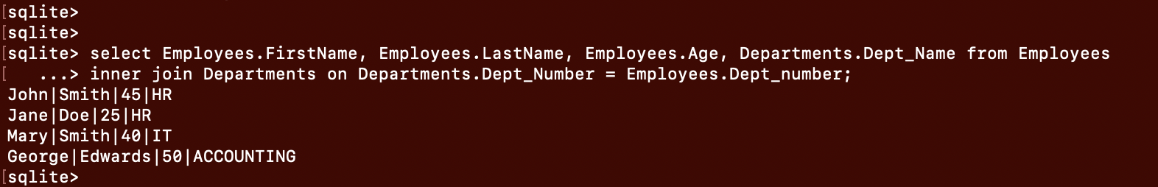

1. SELECT Employees.FirstName, Employees. LastName, Employees. Age, Department.Dept_Name

FROM Employees

INNER JOIN Department

ON Employees.Dept_number = Department.Dept_number

ORDER BY Employees. LastName;

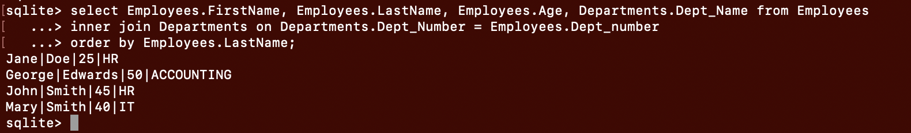

1. SELECT Employees.FirstName, Employees. LastName, Employees. Age, Department.Dept_Name

FROM Employees

INNER JOIN Department

ON Employees.Dept_number = Department.Dept_number

ORDER BY Employees. Age DESC;

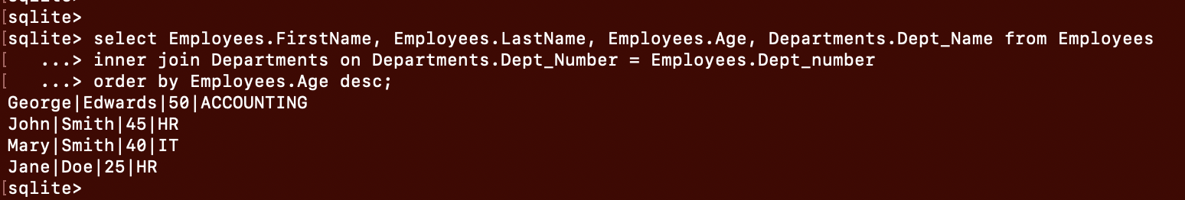

1. Display all details for employees that are not from Chicago

Answer:

SELECT FirstName, LastName, Age, Dept_number, City, State, Salary

FROM Employees

WHERE NOT City = Chicago;

1. Display all details for employees with age 40 or over

Answer:

SELECT FirstName, LastName, Age, Dept_number, City, State, Salary

FROM Employees

WHERE Age > = 40;

1. Calculate and display the total salary of all employees

Answers:

SELECT SUM (Salary)

FROM Employees



1. Add a new employee with the following information:
   * FirstName: Jane
   * LastName: Smith
   * Age: 45
   * Department: Accounting
   * City: Chicago
   * State: IL
   * Salary: 5000

Answer:

INSERT INTO Employees (FirstName, LastName, Age, Dept_number, City, State, Salary)

VALUES (FirstName = Jane, LastName = Smith, Age = 45, Dept_number = 300,

City = Chicago, State = IL, Salary = 5000 );

Note: Given that Account is the department number 300, that was inserted instead. Also, noticed on the results the ‘ID’ is empty thus needs an entry.

1. Increase the salary of John Smith by $2000. Note that this is to add-to and not to replace the existing salary amount.

Answer:

UPDATE Employees

SET Salary = Salary + 2000

WHERE ID = 1

1. Compute and display the total salary by City

Answers:

SELECT SUM (Salary), City

FROM Employees

GROUP BY City;

